**Phase 2**

* Replace 2 additional excel files
  + “Utilization”
    - Used to understand where our work is and what is running in each district
    - Keep a list of employees, who is available and who is on days offSnapshot of a week
    - Has the rotation and is shared with Amy – Group 1,2,3
    - Looked at by district by shift group
    - Summary
      * Shows a 1 week view
      * Show crews per truck and holidays
      * Shows truck working in area
    - Need to look at total vacations by position
  + District Level Tab:

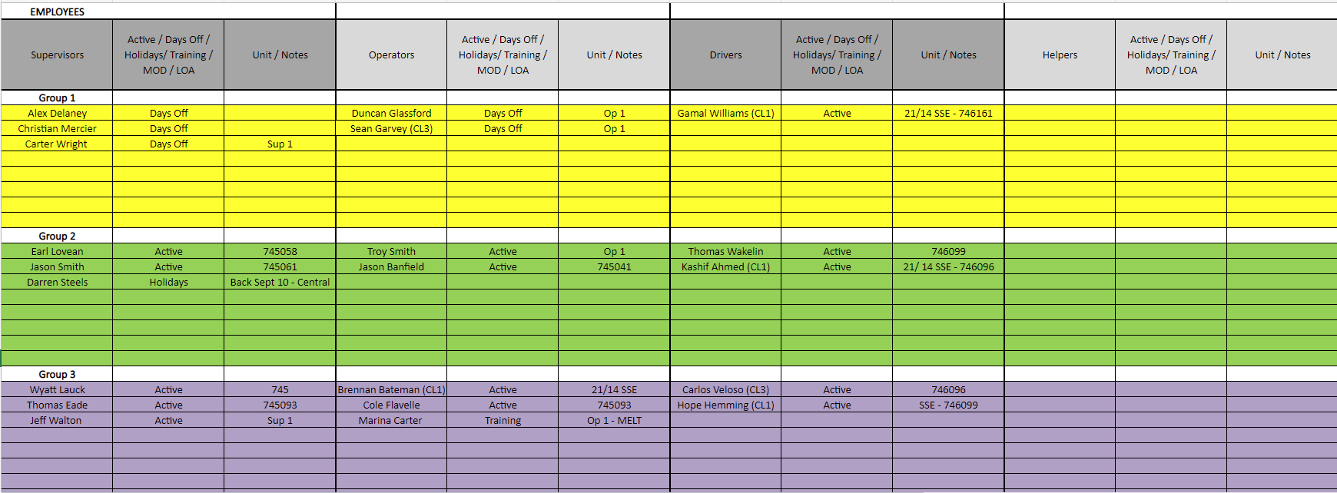

* + Summary Tab:

* + “Truck Board”
    - Keep track of what is hauled to location and what is remaining
    - Show tractor and pumper
    - Show change out crew (Wednesdays)
    - Track product on/moving/needing to move to location
    - Show driver class with people name (GP)
    - Trucks show permits/prorated for different counties
      * Prorated are in AX – only needs to be heavy units and tractors only
      * Permits are in AX – we think…, will be in the unit file
    - Must update eService with crew and asset info

* Rig Activity Forecasting
  + Visualization of people availability – Gant Chart
    - Show vacation days per person - from ADP
      * Already have in the data warehouse
    - Show work roation schedule per person – Group # from ADP “Name”
      * Rotation is set, but may change though email from manager.
      * Changes only entered when emails from manager
        + The emails from manager doesn’t always happen
      * Manager will email when changes are required
        + Doesn’t always happen
      * Changes to ADP occur in time with payrole schedule
      * Rotation schedule naming is varied by district – need to get to the same format - #, color, letter – get consistent – set up meeting with Brett Henry – Use #’s
      * **Is there a way for the managers to enter this data so that Amy doesn’t need to do it**?
        + **This may be able to make it more real time**…
        + **Go from schedule to ADP? (future phase?)**
      * Time and Attendance module of ADP in the schedule data
    - Show training days – not available in ADP, not logged anywhere.
      * Can this be put into LMS or ADP?
      * Ability to make changes to calandar/people gant view
    - Show training certification – available in LMS 365 Certificates – Only Active / latest of the following:
      * Orientations
      * H2S
      * ODA
      * First Aid
      * WHIMIS
      * TDG
    - Sick days are confidential (AMY) – not allowed to be shown
      * Can we track this as **unavailable in ADP**
        + Manager to add once we have a simple way to do so
        + May be in the calendar/people gant view
    - Job Duration
      * Use default values to start
      * Will import job duration by job type and unit count
    - Travel time – look at how to incorporate on either side of the job
      * Needs to be used in the utilization number
      * Can use rig location for distance from service point (District)
      * Can estimate a speed traveled to get time (80 km/hr)
    - Scheduling maintenance is based on severity and operations needs.
      * When selecting a truck to a crew - Show # of workorders against unit and days outstanding
        + Inspections – annuals, cvps, quarterly, iron

Show a count down to when it is due

* + - * Service due - engine service (from emaintain with automatic reset)
        + Show warning from eMaintain - currently set for a 10% warning (in eMaintain)
        + Show work orders have due now, due in a month
      * Maintenance would like to see:
        + What trucks are not scheduled for a job in a district so they can be worked on
        + What trucks are in a district so that they may be worked on when not working (may need mechanic help to do this)
        + Stats on when trucks are busy and when they are not – google bar chart
        + Adding tracking devices to trailers and p-tanks
        + Another gant chart
      * How to add iron – Blair has tracking sheet
        + Future phase
* Visualization of rig/district/truck on map
  + District location of service area
    - Once service area is part of master data, use shading to show district area on the map
* Utilization Calculations
  + Once job is complete:
    - Write to utilization calculations update of job time & travel time, from eService, and redo the utilization calculations
      * Use Arrive on location and depart location to indicate the start and end of a job
    - Will be an estimate until job is complete. Then use eService details to make more accurate